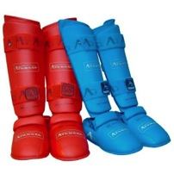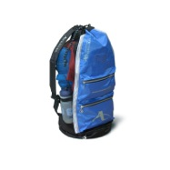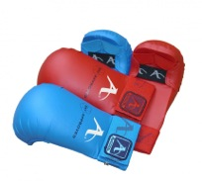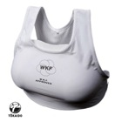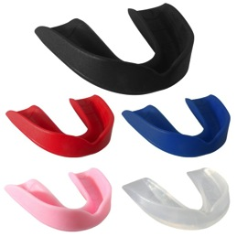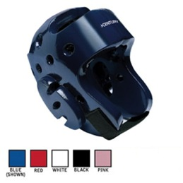

Foot Gear

One size $120

Arawaza Gear Bag $33

XS, S, M, L $70

Helmet

Required Equipment: mouth piece, mitts, foot gear, helmet, groin (m), chest guard (f)

Adult $30

Youth $15

Male

Groin

Protector

NAME:

__________________________

E-Mail:

__________________________

Phone number:

__________________________

Date order placed:

__________________________

Date delivered:

__________________________

TOTAL: ________________

Quantity

Color

Size

___________________________________________________________________________________________________________________________________________________________________________________________________________________________________________________________________________________________________________________________________________________________________________________________________________________________________________________________________________________________________________________________________________________________

Item

Women’s chest

guard

Mouth

piece

Mitts

Arawaza Technical Backpack

Women’s chest

guard

RED, BLUE, WHITE, BLACK or PINK

Youth or Adult $5

Mouth

piece

RED, BLUE, WHITE, BLACK or PINK

S/M or M/L $35

(or) with

Face shield: $60

Helmet

RED or Blue

XS, S, M, L $55

Foot Gear

## Order summary

Order info:

Sparring Equipment Order Form

RED or BLUE

S, M, L $40

Mitts

+

#### (continued)

Lorem Ipsum